MATHS FORMATIVE ASSESSMENT
MULTIPLICATION and DIVISION in FRACTIONS
PYP 6 − NUMBER

Name:

CRITERIA
FRACTIONS
- multiply whole number with proper fraction
- multiply proper fraction with whole number
- multiply proper fraction with other proper fraction
- create the correct sequential steps of multiplication of fractions in picture
- divide whole number with proper fraction
- divide proper fraction with whole number
- divide proper fraction with other proper fraction in equivalent denominator
- divide proper fraction with other proper fraction in different denominator
- divide improper fraction with proper fraction
- create the correct sequential steps of division of fractions in picture

MATHS FORMATIVE ASSESSMENT
MULTIPLICATION and DIVISION in FRACTIONS
PYP 6 − NUMBER

CRITERIA
DECIMALS
- multiply decimal fractions to thousandth or beyond
- multiply decimal with whole number
- multiply decimal with other decimal
- divide decimal fractions to thousandth or beyond
- divide decimal with whole number
- divide whole number with other decimal
- divide decimal with other decimal
PERCENTAGES
- calculate discount in word problem
- calculate tax in word problem
- calculate interest in word problem

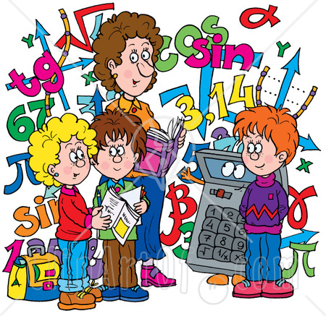
MATHS SUMMATIVE ASSESSMENT
APPLYING FRACTIONS, DECIMALS and PERCENTAGES
PYP 6 − NUMBER

CRITERIA
CALCULATION | - create correct calculation in fractions  - create correct calculation in decimals  - create correct calculation in interest  - create correct calculation in discount  - create correct calculation in tax | - create correct calculation but the wrong result or create wrong calculation but the correct result in fractions  - create correct calculation but the wrong result or create wrong calculation but the correct result in decimals  - create correct calculation but the wrong result or create wrong calculation but the correct result in interest  - create correct calculation but the wrong result or create wrong calculation but the correct result in discount  - create correct calculation but the wrong result or create wrong calculation but the correct result in tax | - make wrong calculation in fractions  - make wrong calculation in decimals  - make wrong calculation in interest  - make wrong calculation in discount  - make wrong calculation in tax
STRATEGIES USED | - have a flexible flair to apply all strategies  - initiatively apply the simplest strategy  - the strategy used is written in the correct sequence | - apply the strategy that teachers suggest or use mostly during explanation  - some strategies used are written in the correct sequence while the other strategies aren’t | - encounter difficulty on choosing and applying the appropriate strategy  - the strategy used is written not in the correct or comprehensible order
QUESTION  COMPREHENSION | - independently grasp the questions without having any difficulties | - requires teachers’ explanation to understand the focus or meaning of the questions | - still have difficulties though teachers’ explanation has been given
SPEED | - finish the task before the designated time or on-time | - able to finish the task after some extra time has been given | - still unable to finish the task though some extra time has been given

